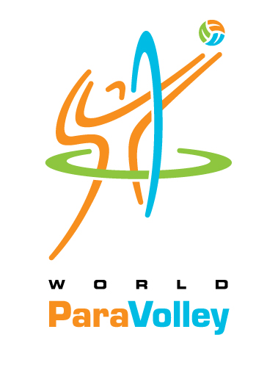 | EXPRESSION OF INTEREST TO BECOME A  LEVEL 1 CLASSIFIER

Please fill out this form if you are interested in becoming a World ParaVolley classifier. Please refer to the World ParaVolley Classification Page under the “medical” tab www.worldparavolley.org/classification/ for more information about becoming a classifier.

Please send this form to our Central Registry at:
classifiereducation@worldparavolley.org and
cc: medicaldirector@worldparavolley.org

Please also send a copy of this form to your respective Zone Head of Classification from the chart below:

PARAVOLLEY AFRICA | PARAVOLLEY EUROPE | PARAVOLLEY ASIA-OCEANIA | PARAVOLLEY  PAN-AMERICAN
TINA SACHS | MAIJU MARJAMAKI | DR. JINZHONG MA | SARO KERESTECIYAN
South Africa | Finland | China | Canada
Email:  tina.classification@gmail.com | Email:  maiju@paravolley.eu | Email:  majinzhong007@sina.com | Email:  datamanager@worldparavolley.org

If you are interested in becoming an International World ParaVolley classifier, it will require participation in classification courses to learn the classification rules and a time commitment for assisting with classification in your area.

Name:

Address:

Phone number: |  | Mobile number:
Email: |  | Profession  Physiotherapist Medical Doctor
Team Affiliation, if any:

Experience in Volleyball, ParaVolley or other sports for persons with disabilities:
Number of years in ParaVolley or other sports listed above
In your profession, please describe your main areas of experience or specialization
What do you hope to do with your L2 training once completed?

We hope that you will consider this opportunity to become involved in World ParaVolley. It is an exciting sport!

